CASE STUDY – FILMSTREAMING

After analyzing the data given here are the few insights that can be drawn from the data.

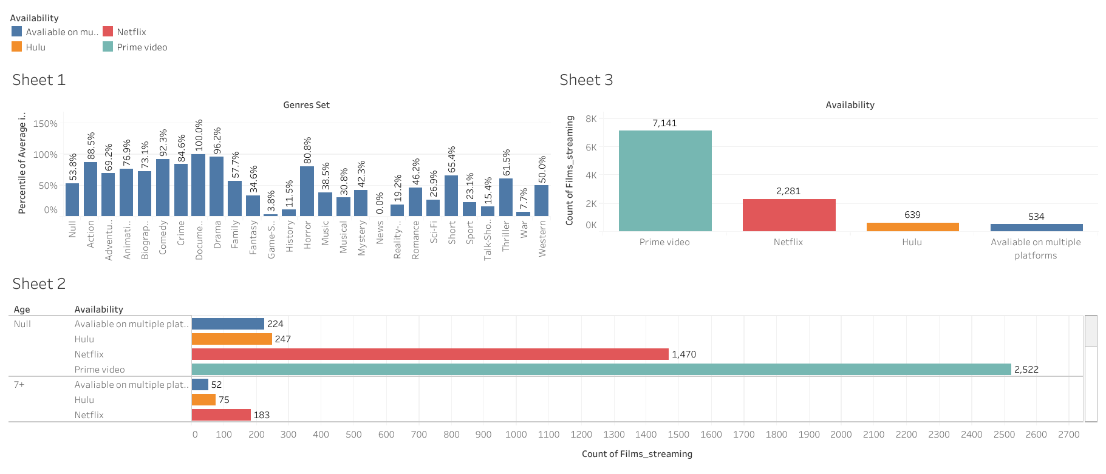

**DASHBOARD 1**

1. **Genre Preferences**: Investigated which genres have more IMDB rating from which Documentary, Drama and comedy stood top 3 whereas news, game-show and war are bottom 3.
2. **Availability Distribution:** Visualized the availability of films across different streaming platforms (Netflix, Prime Video, Hulu, etc.) and even segregated them age-wise.

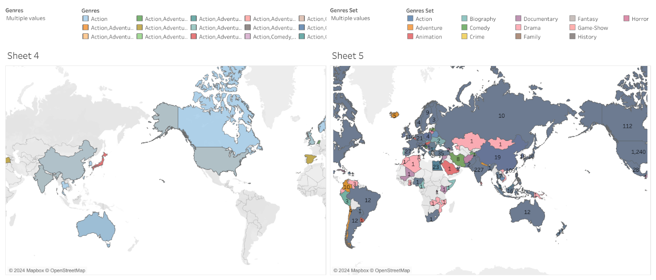

**DASHBOARD 2**

1. **Country-wise Analysis:** The genres in particular country and the count of films in each country can be depicted from this dashboard.

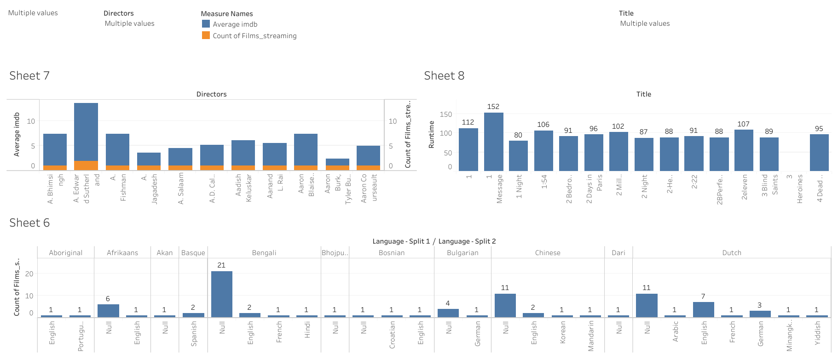

**DASHBOARD 3**

1. **Language Analysis:** Explored no. of films patterns based on language. English language dominates the platform. Viewers prefer content in their native language which is why there are more native languages dubbed films.

2. **Director Influence:** Analysed the popularity of films based on the directors. You can view the no. of films and their average IMDB rating for each director.

3**. Content Duration:** The content duration for each film is shown accordingly.

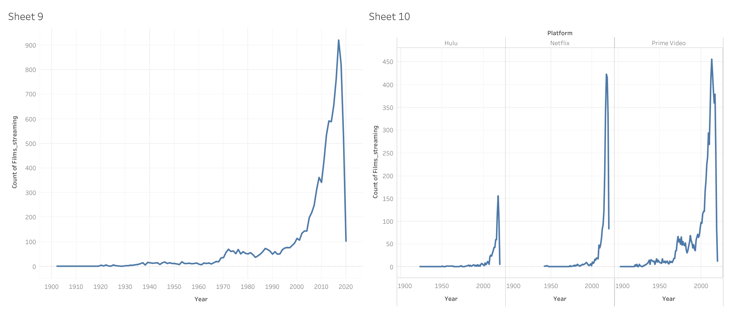

**DASHBOARD 4**

1. **Production Year Treads:** Examined the trends over different production years according to the count of films and the no. of films in different platforms.
   * The year 2017 has the highest count of films which is 921.
   * In Hulu platform, the year 2018 has highest count of films which is 156.
   * In Netflix platform, the year 2017 has highest count of films which is 423.
   * In Prime Video platform, the year 2013 has highest count of films which is 436.